Sixth Form Attendance Policy

One of our key aims of NES Sixth Form is to ensure that all of our students leave with the best grades that they are capable of achieving. Educational studies have consistently shown that the most successful students are those that have a very high attendance at school.
As such we will be monitoring attendance very closely and if students hit any of the trigger points in terms of number of days off, then the following actions will be put into place:
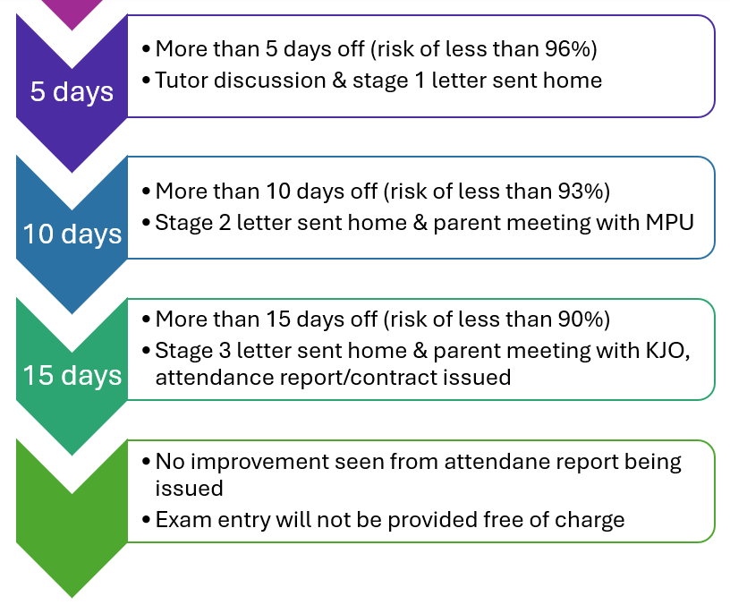
If a student is absent from school for 4 consecutive weeks, then we legally have to off-role the student: according to the ESFA’s funding regulations for post-16 provision 2024-2025, section 5, paragraph 157, institutions must withdraw students from their programmes if they do not return to learning after being absent for 4 weeks (28 consecutive days).
I very much hope that these steps will not need to be actioned and appreciate your support with students’ attendance.

